*"""  
Define a subprogram that will ask the user to pick a low and a high number,  
and then generate a random number between those two values  
and store it in a variable called “comp_num”.  
Define another subprogram that will give the instruction  
“I am thinking of a number…”  
and then ask the user to guess the number they are thinking of.  
Define a third subprogram that  
will check to see if the comp_num is the same as the user’s guess.  
If it is, it should display the message “Correct, you win”,  
otherwise it should keep looping,  
telling the user if they are too low or too high and asking them to guess again  
until they guess correctly. Upload the program in word file  
  
"""*import random  
  
  
def comp_num(): # the first subprogram pick a low and a high number,  
 global comp_num  
 print("pick a low and a high number :".center(80, "*"))  
 try:  
 num1 = int(input("Enter low number : ".rjust(50)))  
 num2 = int(input("Enter high number: ".rjust(50)))  
 except:  
 print("Something went wrong\nplace sure input number")  
 try:  
 comp_num = random.randint(num1, num2)  
 except:  
 print(("You main Low: " + str(num2) + " and High :" + str(num1)).center(80))  
 num1, num2 = num2, num1  
 comp_num = random.randint(num1, num2)  
  
  
def guess(agin=0): # the second subprogram guess the number they are thinking of.  
 global guess_num  
 if agin == 0:  
 print("I am thinking of a number… *_* ".center(80,"^"))  
 print("Guess the number they are thinking of :".rjust(60), end="")  
 else:  
 print("Try Try ^_^ ,Enter another number :".rjust(60), end="")  
 try:  
 guess_num = int(input())  
 except:  
 print("Something went wrong\nplace sure input number")  
 return  
  
  
def check(): # Third subprogram :guess correctly or not  
 while comp_num != guess_num:  
 if comp_num > guess_num:  
 print("too low -_- guess again".center(80,"-"))  
 guess(1)  
 else:  
 print("too high -_- guess again".center(80))  
 guess(1)  
 else:  
 print("Correct, you win ^_^".center(80))  
  
  
def guessGame(): # Tha main function for the Game  
 comp_num()  
 guess()  
 check()  
  
  
guessGame()

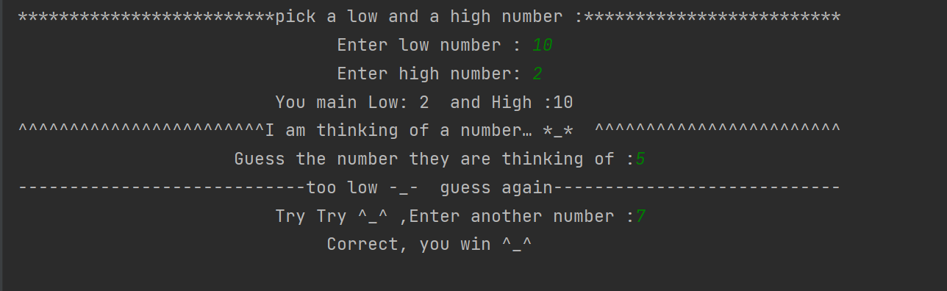**OUT_PUT:**